Soy sauce
Soy sauce is a liquid food condiment prepared from fermented wheat and soybean with the help of molds, bacteria, and yeasts. Soy sauce is a seasoning agent with a salty taste. . The sauce is made by fermentation of a combination of soy beans and wheat in water and salt.
Of the many Oriental fermented products, soy sauce is the one most widely consumed in China, Japan, Korea and other Asiatic countries as a condiment and coloring agent in preparation of foods and for table use. It is a dark brown liquid, stable at ambient temperature, which does not require refrigeration during storage due to its low water activity and high salt content
Production process of Soy sauce
Soy sauce is made by fermentation of a combination of soy beans, wheat grain, water and salt.
The processes for production of fermented soy sauce consist of three major steps namely-
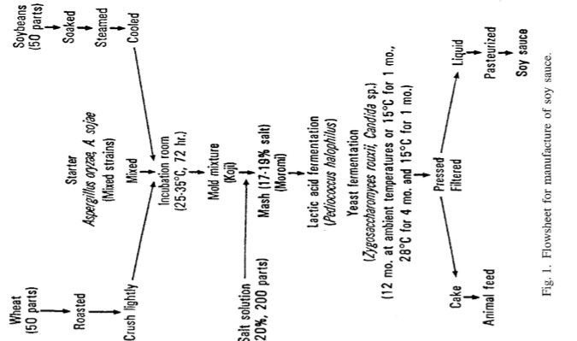
- Koji production
- Brine formation
- Refining. A flow sheet for manufacture is shown in Fig. 1.

- Koji production
In making regular soy sauce, the cooked soy beans (or defatted soy flakes) are mixed with an equal amount of roasted wheat and then inoculated with 0.1-0.2% of starter mold (Aspergillus oryzae or Aspergillus sojae) in wooden trays, each loaded with a 3-5 cm thickness of the fermenting Koji.
The ratio of wheat to cooked soybean may vary, depending on the type of soy sauce m be prepared. After incubation at 25°C for 72 h, the Koji becomes a greenish yellow mass as a result of mold growth and sporulation.
The important factors are selection of the best strains of Aspergillus oryzae and Aspergillus sojae and controlling the product temperature in that range during the Koji fermentation process.

- Brine fermentation
The second step in making fermented soy sauce is brine fermentation.
It utilizes the lactic bacterium, Pediococcus halophiIus and the yeasts Zygosaccharomyces rouxii and Candida species both of which tolerate a salt concentration of 20 g per 100 ml.
The brine effectively prevents growth of undesirable microorganisms. The harvested Koji is mixed with 20% salt brine, and transferred by means of a spiral pump into deep fermentation steel tanks coated with epoxy resins on the interior. The resultant mixture is called moromi mash.

It is important to control the microorganisms in the brine fermentation. The specially selected Pedicoccus halophilus is cultured and added to the mash. To control its growth rate it is necessary to keep the fermenting mixture at 15°C for the first month, allowing the pH of the mash to decrease slowly from 6.5 to 5.0. Then cultures of Z rouxii and Candida species are added as a starter. The temperature of the moromi is allowed to rise slowly to nearly 28°C until vigorous alcoholic fermentation starts. The temperature in the tank can be controlled by coil type heat exchangers with mixing devices, thermocouples, and control systems.

During the brine fermentation, the pH of the mixture drops from 6.5 to 5.0 in the first month at 15°C. This is followed by fermentation at 28°C for four months. Sometimes it is necessary to add more pure cultures of P. halophilus and Z. rouxii and Candida species to the moromi mash during the fermentation.

- Refining
The final process in soy sauce fermentation is refining which includes pressing, filtration, pasteurization and packaging.

The aged moromi is pressed in a vertical automatic press to separate the soy sauce from the residue. After pressing, the filtered raw soy sauce is pasteurized in a heat-exchanger at 70-80°C for a few minutes to ensure clarity, to inactivate residual enzymes, and to inactivate any undesirable microorganisms. It may be necessary to clarify the soy sauce additionally by centrifugation or sedimentation. The sauce is treated with caramel as a coloring agent, and then packaged either in clean glass bottles, enameled gallon cans or in plastic containers.

Much expertise is needed to produce a soy sauce that is attractive in flavor and taste, stable on storage at room temperature, and acceptable to the consumer. The quality assurance group must check the pH, acidity, amino nitrogen, salt content, color, microbial contamination, and sensory attributes: color, aroma and flavor of the product.

Reference
Luh .S. B (1995), Industrial production of soy sauce, Journal of industrial Microbiology 14: 467-471

